Advantages of Using Messaging System

1. 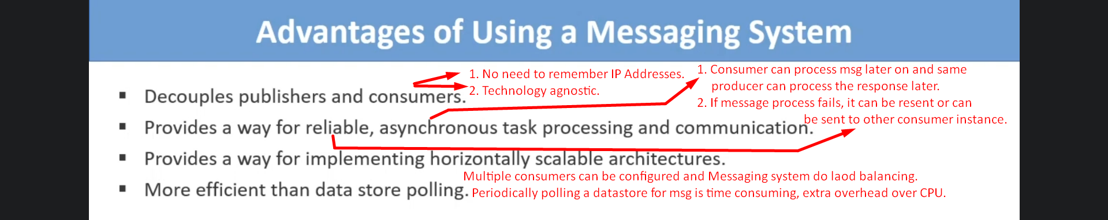 **Decouples publishers and consumers**:
   1. Message Publisher and Message Consumer need not to know about their IP addresses.
   2. They don’t need to know even about the technologies in which they are implemented.
   3. They only need to know about the message format which is usually JSON format.
2. **Provides a way for reliable, asynchronous task processing and communication** 
   1. **Reliable:**
      1. Publishers can publish messages even though no consumer is running and all those messages would be queued and saved.
      2. If one consumer fails to process a message, the message can be resent or sent to another consumer.
   2. **Asynchronous task processing and communication:**
      1. The consumers can carry later on and same is for response from consumers to publishers.
3. **Provide a way for implementing horizontally scalable architectures**
   1. If existing number of consumers are not enough to process messages in time, we can increase them.
   2. Messaging system also works a load balancer among the consumers.
4. More efficient than data store polling
   1. Periodically, polling the datastore for new tasks or messages is a slow process and increases the workload.

Use-Cases

1. **Use Case 01**:  
   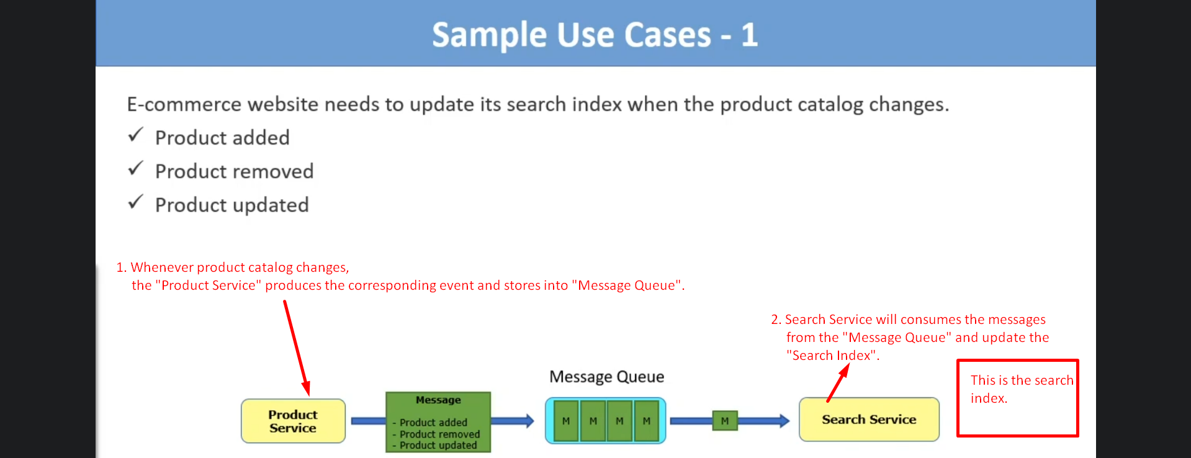
   1. E-commerce website needs to update its **search service index** when a **product catalog changes**.  
      **such as** Adding, removing, updating existing product.
   2. There is a **search service** which indexes all the products in the product catalog based on the key passed by a user.
2. **Use-Case 02**:
   1. 